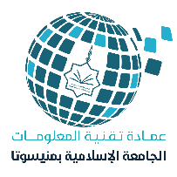

The test of 40 students in the first level has been completed
The monitoring of the final exam scores has been followed up on the portal
The curriculum unit is being followed up to develop the curricula of the next academic stages
All the required support was provided to 4 students in the stage of complementary research in the master's degree
All lectures were provided for all subjects for the second semester
The test of 32 students in the second level has been completedالنص
The test of 21 students at the third level has been completedالنص
The test of 4 master's students has been completed
8
6
7
5
3
4
2
1
لــعــام 2024 م
تقرير بإحصائية إنجازات قسم اللغة الانجليزية
فـي الجامـعة خــلال شهر فبراير

